**BANK LOAN REPORT QUERY DOCUMENT**

1. **BANK LOAN REPORT | SUMMARY**

**KPI’S:**

**Total Loan Applications**

**SELECT COUNT(id) Total_Loan_Applications FROM financial_loan;**



**MTD_Total Loan Applications**

**SELECT COUNT(id) MTD_Total_Loan_Applications FROM financial_loan**

**WHERE MONTH(issue_date) = 12 AND YEAR(issue_date) = 2021;**



**PMTD_Total Loan Applications**

**SELECT COUNT(id) PMTD_Total_Loan_Applications FROM financial_loan**

**WHERE MONTH(issue_date) = 11 AND YEAR(issue_date) = 2021;**



**Total Funded Amount**

**SELECT SUM(loan_amount) Total_Funded_Amount FROM financial_loan;**



**MTD_Total Funded Amount**

SELECT SUM**(Loan_Amount) MTD_Total_Funded_Amount** FROM **financial_loan**

WHERE MONTH**(issue_date)= 12** AND YEAR**(issue_date)=2021;**

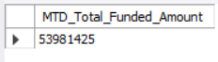

**PMTD_Total Funded Amount**

SELECT SUM**(Loan_Amount) PMTD_Total_Funded_Amount** FROM **financial_loan**

WHERE MONTH**(issue_date)= 11** AND YEAR**(issue_date)=2021;**



**Total Amount Received**

SELECT SUM**(total_payment) Total_Amount_Received** FROM **financial_loan;**



**MTD_Total Amount Received**

SELECT SUM**(total_payment) MTDTotal_Amount_Received** FROM **financial_loan**

WHERE MONTH**(issue_date)= 12** AND YEAR**(issue_date)=2021;**

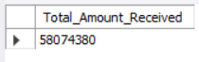

**PMTD_Total Amount Received**

SELECT SUM**(total_payment) PMTD_Total_Amount_Received** FROM **financial_loan**

WHERE MONTH**(issue_date)= 12** AND YEAR**(issue_date)=2021;**



**Average Interest Rate**

SELECT AVG**(int_rate)*100 Average_Interest_Rate** FROM **financial_loan;**



**MTD_Average Interest Rate**

**SELECT AVG(int_rate)*100 MTD_Average_Interest_Rate FROM financial_loan**

**WHERE MONTH(issue_date)=12 AND YEAR(issue_date)=2021;**



**PMTD_Average Interest Rate**

**SELECT AVG(int_rate)*100 PMTD_Average_Interest_Rate FROM financial_loan**

**WHERE MONTH(issue_date)=11 AND YEAR(issue_date)=2021;**



**Average Debt-to-Income Ratio (DTI)**

**SELECT AVG(dti)*100 Average_Debt_to_Income_Ratio FROM financial_loan;**



**MTD_Average Debt-to-Income Ratio (DTI)**

**SELECT AVG(dti)*100 MTD_Average_Debt_to_Income_Ratio FROM financial_loan**

**WHERE MONTH(issue_date)=12 AND YEAR(issue_date)=2021;**



**PMTD_Average Debt-to-Income Ratio (DTI)**

**SELECT AVG(dti)*100 PMTD_Average_Debt_to_Income_Ratio FROM financial_loan**

**WHERE MONTH(issue_date)=11 AND YEAR(issue_date)=2021;**



**GOOD LOAN ISSUED**

**Good Loan Percentage**

**SELECT (COUNT(CASE WHEN loan_status="Fully Paid" OR loan_status="Current" THEN id END) * 100)**

**/ COUNT(id) Good_loan_percentage from financial_loan;**



**Good Loan Application**

**SELECT COUNT(id) Good_Loan_Applications from financial_loan**

**WHERE loan_status="Fully Paid" OR loan_status="Current";**

**OR**

**SELECT COUNT(id) Good_Loan_Applications from financial_loan**

**WHERE loan_status IN("Fully Paid" ,"Current");**

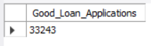

**Good Loan Funded Amount**

**SELECT SUM(loan_amount) Good_Loan_Funded_Amount from financial_loan**

**WHERE loan_status="Fully Paid" OR loan_status="Current";**

**OR**

**SELECT SUM(loan_amount) Good_Loan_Funded_Amount from financial_loan**

**WHERE loan_status IN("Fully Paid" ,"Current");**



**Good Loan Total Received Amount**

**SELECT SUM(total_payment) Good_Loan_Total_Received_Amount from financial_loan**

**WHERE loan_status="Fully Paid" OR loan_status="Current";**

**OR**

**SELECT SUM(total_payment) Good_Loan_Total_Received_Amount from financial_loan**

**WHERE loan_status IN("Fully Paid" ,"Current");**



**BAD LOAN ISSUED**

**Bad Loan Percentage**

**SELECT (COUNT(CASE WHEN loan_status="Charged Off" THEN id END) * 100)**

**/ COUNT(id) Bad_loan_percentage from financial_loan;**

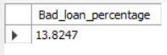

**Bad Loan Application**

**SELECT COUNT(id) Bad_Loan_Applications from financial_loan**

**WHERE loan_status="Charged Off";**

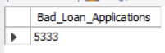

**Bad Loan Funded Amount**

**SELECT SUM(loan_amount) Bad_Loan_Funded_Amount from financial_loan**

**WHERE loan_status="Charged Off";**

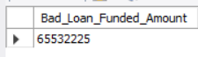

**Bad Loan Total Received Amount**

**SELECT SUM(total_payment) Bad_Loan_Total_Received_Amount from financial_loan**

**WHERE loan_status="Charged Off";**

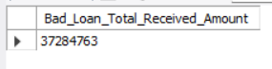

**Loan Status Grid View**

**SELECT**

**loan_status,**

**COUNT(id) Total_loan_Application,**

**SUM(loan_amount) Total_Funded_Amount,**

**SUM(total_payment) Total_Amount_Received,**

**AVG(int_rate * 100) Average_Interest_Rate,**

**AVG(dti * 100) Average_Debt_to_Income_Ratio**

**FROM financial_loan**

**GROUP BY loan_status**

**ORDER BY loan_status DESC;**

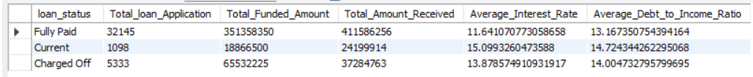

**SELECT loan_status, SUM(loan_amount) MTD_Total_Funded_Amount, SUM(total_payment) MTD_Total_Amount_Received**

**FROM financial_loan WHERE MONTH(issue_date)= 12 AND YEAR(issue_date)=2021 GROUP BY loan_status ORDER BY loan_status DESC;**

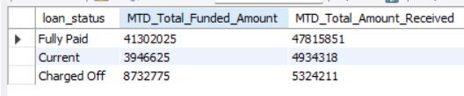

**SELECT** **loan_status,** **SUM(loan_amount) PMTD_Total_Funded_Amount,** **SUM(total_payment) PMTD_Total_Amount_Received**

**from** **financial_loan** **WHERE** **MONTH(issue_date)= 11** **AND** **YEAR(issue_date)=2021** **group** **by** **loan_status** **order** **by** **loan_status desc;**

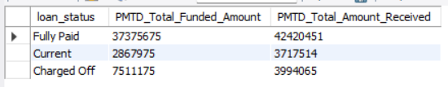

1. **BANK LOAN REPORT | OVERVIEW**

**Monthly Trends by Issue Date**

**SELECT MONTH(issue_date) AS Month_Num,**

**MONTHNAME(issue_date) AS Month_Name,**

**COUNT(id) AS Total_loan_Application,**

**SUM(loan_amount) AS Total_Funded_Amount,**

**SUM(total_payment) AS Total_Amount_Received**

**FROM financial_loan**

**GROUP BY Month_Num , Month_Name**

**ORDER BY Month_Num;**

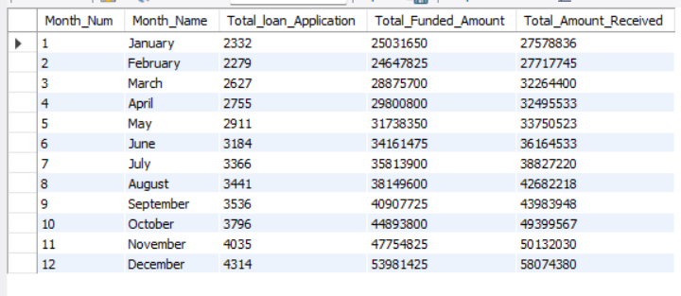

**Regional Analysis by State**

**SELECT address_state AS States,**

**COUNT(id) AS Total_loan_Application,**

**SUM(loan_amount) AS Total_Funded_Amount,**

**SUM(total_payment) AS Total_Amount_Received**

**FROM financial_loan**

**GROUP BY address_state**

**ORDER BY address_state;**

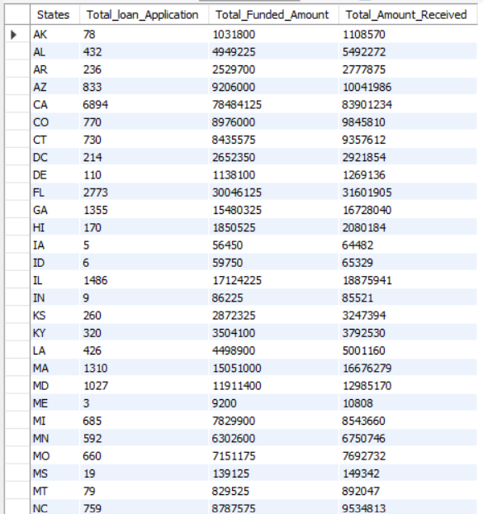

**Loan Term Analysis**

**SELECT term AS Term,**

**COUNT(id) AS Total_loan_Application,**

**SUM(loan_amount) AS Total_Funded_Amount,**

**SUM(total_payment) AS Total_Amount_Received**

**FROM financial_loan**

**GROUP BY term**

**ORDER BY term;**

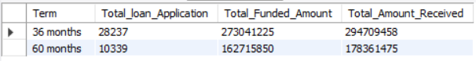

**Employee Length Analysis**

**SELECT emp_length,**

**COUNT(id) AS Total_loan_Application,**

**SUM(loan_amount) AS Total_Funded_Amount,**

**SUM(total_payment) AS Total_Amount_Received**

**FROM financial_loan**

**GROUP BY emp_length,**

**ORDER BY emp_length;**

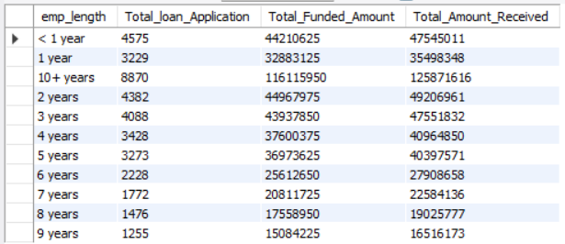

**Loan Purpose Breakdown**

**SELECT purpose,**

**COUNT(id) AS Total_loan_Application,**

**SUM(loan_amount) AS Total_Funded_Amount,**

**SUM(total_payment) AS Total_Amount_Received**

**FROM financial_loan**

**GROUP BY purpose,**

**ORDER BY purpose;**

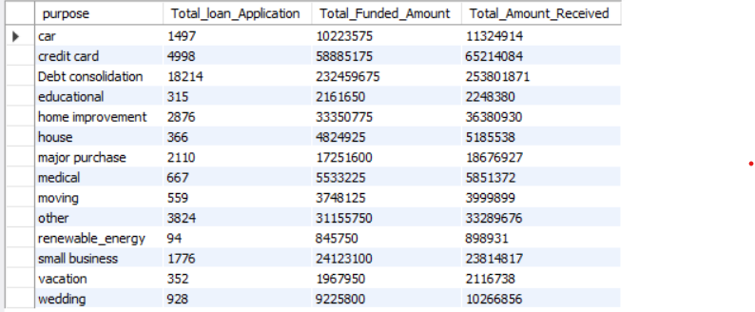

**Home Ownership Analysis**

**SELECT home_ownership,**

**COUNT(id) AS Total_loan_Application,**

**SUM(loan_amount) AS Total_Funded_Amount,**

**SUM(total_payment) AS Total_Amount_Received**

**FROM financial_loan**

**GROUP BY home_ownership,**

**ORDER BY COUNT(id) DESC;**

